**Case Study 5**

**Task 1: User Interface Design**

Login Interface

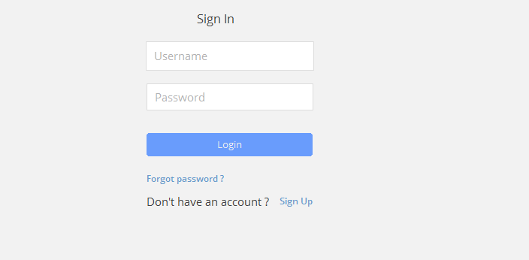

Stock Management

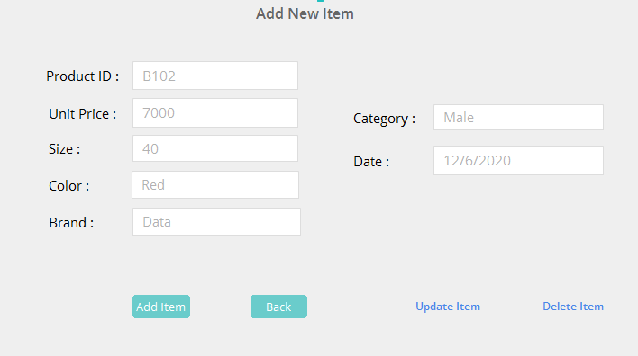

Stock Report

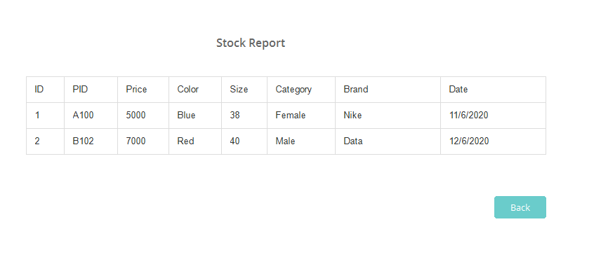

Update Password

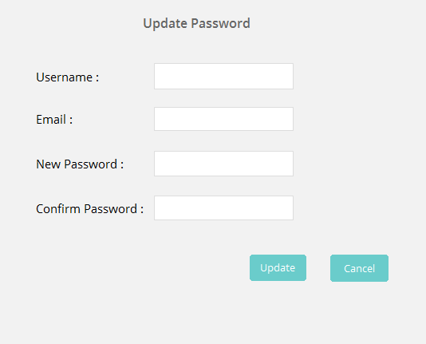

Staff registration

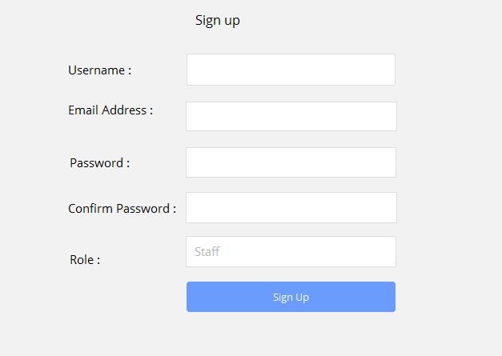

New Service

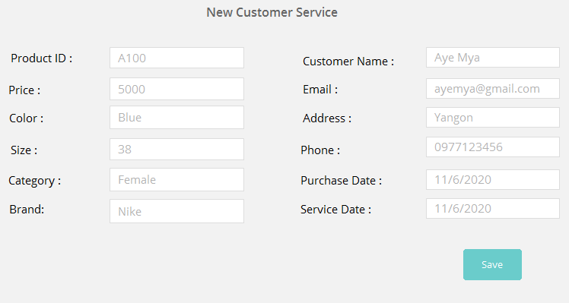

Service Report

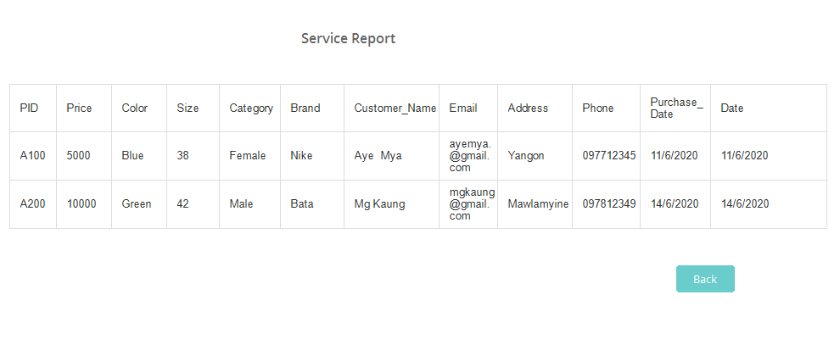**Task 2: Development vs Deployment Plan**

This is the most important part for software development. The system goals define the expected project results together with the required development constraints. Information may be extracted from the project proposal and project requirement specification and completed, if required. In the development plan, considered the following various categories of project:

* Functional goals
* Strategic goals
* Technological goals(tools, methods)
* Quality goals
* Other goals(usability, portability)
* Time
* Cost

Before we hand over the project we need to justify the system requirements so that the client can run the system without any obligations and dissatisfactions. For that below is our requirements:

Software requirements

* Operating System: Windows ( 7, 8, 8.1, 10) or Mac, Linux
* Database Management System: MySql
* IDE (Integrated Development Environment): Eclipse
* Other: Postman , Spring Boot Framework

Hardware Requirements

* RAM: Minimum 2GB or higher.
* HDD: Minimum 50 GB.
* Processor: Intel core i3

**Task 3: Testing type**

Functional Testing:

* Unit Testing
* Integration Testing
* System Testing
* Interface Testing
* Regression Testing
* Beta/Acceptance Testing

Non-functional Testing:

* Performance Testing
* Load Testing
* Stress Testing
* Volume Testing
* Security Testing
* Compatibility Testing
* Install Testing
* Recovery Testing
* Reliability Testing
* Usability Testing
* Compliance Testing
* Localization Testing

**Task 4: Test Plan**

Test 1

* Test Title: Stock Management
* Test Data: Users need to click Stock Management for managing stock.
* Expected Result: It will redirect to admin stock management panel where admin can update, delete, and retrieve stock.

Test 2

* Test Title : Stock Report
* Test Data: Users need to click Stock Report for viewing stock.
* Expected Result: System will view all the records of the stock.

Test 3

* Test Title: Staff Registration
* Test Data: Users need to click Staff Registration for registration.
* Expected Result: System will register new staff.

Test 4

* Test Title : New Service
* Test Data: Users need to click New Service for adding customer service.
* Expected Result: New customer will be added into database.

Test 5

* Test Title : Service Report
* Test Data: Users need to click Service Report for viewing customer service.
* Expected Result: System will view all the records of the customer service.